A study on Recent VR Platform and Applications
Xiao-Yun Duan¹, Soo-Kyun Kim¹*

¹Department of Game Engineering, Paichai University, Daejeon, South Korea
¹* Corresponding Author: Soo-Kyun Kim (kimsk@pcu.ac.kr)

(Received/Accepted:12.03.2015/02.01.2016)

Virtual Reality (VR) technology has enormous potential, changing the future for a number of fields. Since 2014, with the rapid development of VR both in hardware and software fields, VR is mostly being applied in medicine operation training, architecture design, business, education, and manufacturing, and there are various of different VR devices as we know. This survey presents the descriptions of categories of VR system, the adverse effects to human health and hardware limits of VR, and finally describes the VR devices and its applications.

Keywords: Head-Mounted Displays, Platform, Devices, Application, Virtual Reality

- INTRODUCTION
Recent advancements in Virtual Reality (VR) have been widely shown in many applications such as design, education, training, games and medicine. By artificially stimulating our senses, VR makes it possible to trick our sense/body into accepting another version of reality. VR technology has enormous potential, changing the future for a number of fields. To experience a VR device or an application there is basic knowledge that should know about VR.
1.1 Virtual Reality
Virtual reality, VR for short, uses a computer that creates a simulated 3D world. Jerald et al, [1] presented that VR is defined as “a computer-generated digital environment that can be experienced and interacted with as if that environment were real” and asserted that VR is communication, they emphasized the importance of human factor that influence the interaction between the VR system and the users [1]. VR uses computer or other devices, simulates and generates a virtual world that the users can interact with, and get immersive experience.
Virtual reality has 3 main characteristics, namely immersion, real-time interactivity, and imagination. Immersion is the core characteristic. It is the objective degree to which a VR system and application projects stimulates the sensory receptors of users in a way that is extensive, matching, surrounding, vivid, interactive, and plot informing [2], Anyone who experiences it can get the real sense of seeing, hearing, touching and smelling just like in the real world. Second, real-time interactivity is the basic requirement, as users interact with the environment in the real world. Users’ immersion will be broke if the interaction is unnatural or has time latency. Third, imagination is the ideal purpose of VR, which is also means creativity, the very beginning of VR world, VR can be made just like the real or nonexistent things, through the experiences users get new knowledge and ideas and can establish new cognition.

1.2 VR System
VR system has four main categories as follows Desktop VR system, Augmented VR system, Immersive VR system (which is consists of HMD-VR, Projection display based-VR, telepresence system VR), and Distributed VR (DVR) system [3]. Here we show the most common form: HMD-VR Immersive VR system. As shown in fig.1, VR system consists of 4 parts such as VR goggles, host system, tracking system, and control system [4], the VR goggles generally has the display integrated screen or smartphone screen inside of it, some also has earphone to get the sound, it can track the user’s head movements; the control system is the interaction part that users use their hands Grabbing or touching the objects in the virtual reality world; the host system gets the information from the tracking system and the control system, processes it and react to them.
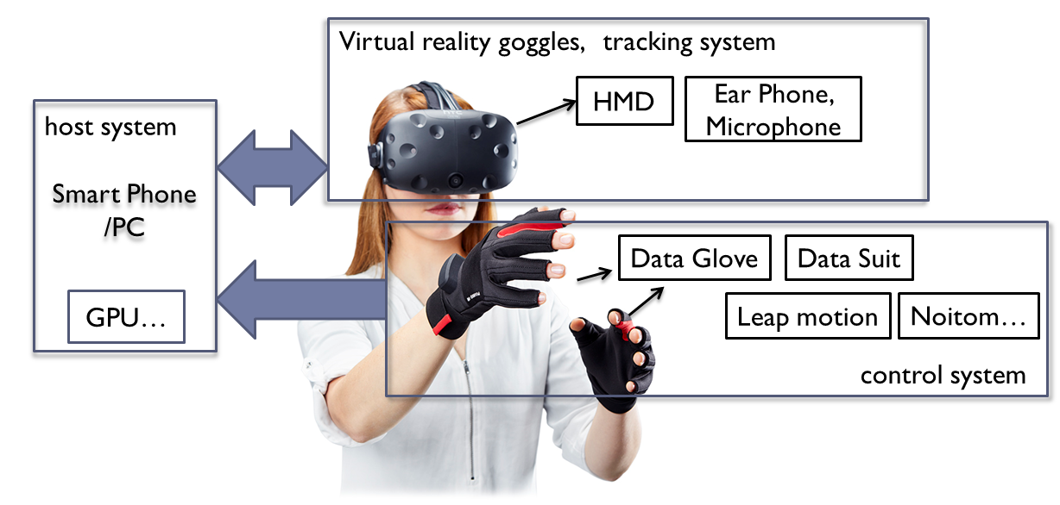
Fig.1. Overview of VR System

- LIMITS OF VR

Since 2000s, there are plenty of original stage products published, however because of the limits of VR technology, it is not so popular yet. Among the reasons, one is its hardware limits which can make users feel vertiginous after a longtime use, The VR developers can raise to the challenges on hardware limits and adverse effects on human health. This section describes the hardware limits of VR.

- Latency: the sum of delays of rendering, application, display, tracking, and synchronization among components. Low-accuracy head trackers result in seeing the world from an incorrect viewpoint.

- Vertigo: There are two main causes of vertigo: First, the body has moved and the picture has not moved, Second, the picture had moved but the body remained motionless. The virtual character’s movement in the VR world cannot reflect by the real human body such as you may be on a visual Roller coaster while your body is stationary, this confuse the vestibular system, which cause vertigo [5].

- Headset Fit: the degree of comfortable users feel, among this is the viewing angle. If visual range is bigger than the screen it’s easy to affect the viewing experience and immersion through eye movement.

- Portability: Mainly refer to the weight and battery life, heavy equipment, after long periods of operation can make user discomfort and add fatigue. For the wired devices, it’s difficult for the user to move around freely; for the VR-all-in-one devices, short battery life and weight are the key limiting factors.

- Interaction way: Some unnatural ways such as touch the screen; press a magnet button; Control a Joypad adaptor, or use single Bluetooth; Sensor Devices: The force sensation, haptic sensor cannot provide an accuracy control for the users.

In addition, there is another saying which seems more persuasive, the higher quality Virtual World brings deeper immersions to the users, However, this means broke the connection between people and the real world and other people, although user can interaction in the VR space, that is very limited for it reduce the authenticity and naturalness greatly, Any technology that goes Widespread popularity must be Dense Communication[5], hence the combination of the VR and the real world which is called Augmented Reality AR for short has attracted more and more attentions.

- VR DEVICES AND APPLICATIONS
3.1 VR devices
During 2017, Many Major companies have launched new services or update their Hardware devices. There are a lot of promising headsets across a lot of different price and power spectrums. Oculus has released the consumer-ready Rift, HTC and Valve have put out the Steam-friendly Vive, Sony has launched the excellent PlayStation VR, Samsung recently added a separate controller to its Gear VR, and Google's Daydream is steadily growing from the remains of Google Cardboard. Meanwhile, Microsoft's Windows 10 mixed reality platform and a variety of hardware manufacturers working on it are waiting in the wings [6].

The composition of the VR goggles - HMD (Head- Mounted Displays) can be classified as PC+VR, Mobile +VR, and VR-all-in-one. PC+VR devices have high performance which is depends on the connected PC, more expensive but lower portability than other two kinds. Mobile +VR devices are easy and convenient for beginners, and its better portability make it the most potential one in the future VR development, VR-all-in-one device is also portable, however disputed for its heavy weight and short battery life. All these categories have the vertigo problems. Fig.2 shows the representative brands of VR HMDs.

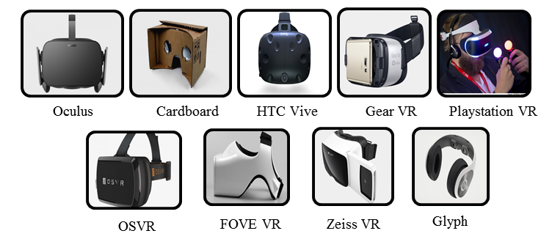
Fig.2. Representative brands of VR devices

- Oculus Rift: Gone public on March 25 by Facebook, 2016, it is a PC-VR device that has configured screen and sensing device, the headset device two OLED panels, each having a resolution of 1080×1200, the connecting PC must have a high configuration, and it also has controller devices.

- Sony PlayStation VR: Launched in October 2016 By Sony, it is also a PC-VR device that has an OLED, and the resolution of each eye is 960×1080 pixels [7], the controller is called PlayStation MOVE, it has a small loss of immersion sense and comparatively cheap compared to the others.

- HTC Vive Pre: Launched at Consumer Electronics Show 2016, known as HTC Vive Pre [8], the two display screen has a refresh rate of 90 Hz, and resolution of 1080×1200. The controller is more convenience and looks lighter the front-facing camera called “Chaperone” [9]. HTC recently unveiled a Vive headset that doesn't require a connected PC which is called the Vive Standalone, that was shown off at the ChinaJoy entertainment expo in July. Ever since this being launched in China, it is not exactly a PC+VR HMD anymore.

- Samsung Gear VR: the latter half of the year of 2014, Samsung published the first generation mobile-VR device; it is only supported by Galaxy Note 4. While at MWC 2016 (Mobile World Congress), new generation Gear VR supported by Galaxy S7/S7 Edge, Note5，Note4，Galaxy S6, S6 Edge and S6 Edge+ was published.

- Google Cardboard: Google published Cardboard in 2014 enable low-cost($2) VR using existing smart phones, and has a magnet button as the input device.

- FOVE VR: The first eye tracking VR headset, add two infra-red cameras below the lens and not disturb users’ experience, It can aim the users’ eyes, tracking user’s viewpoint, This enables the graphics engine to adjust focus and allocate rendering resources accordingly look, laugh, and communication with character just like in the real world[10].

- Avegant Glyph: it has no traditional screen, what the user see is the projection on users’ eyes and for this reason it a 120Hz Refresh Rate and 45°view angle, the high Refresh Rate leads to no latency, the narrow view angle make less user immersive.

- Google Daydream VR: it has been published on May, 2016 in Google I/O Conference, it optimized the algorithm, therefore it can reduce latency and vertiginous sensation effectively, it support various smart phones, and the Pixel phone develop by Google is the first one supported. The developers also further enriched software in the fields of watching movies, playing games, watching games.

- Pico Neo and DeepoonM2 - In China, the latest and the most popular VR-all-in-one devices are Pico Neo and DeepoonM2 for they are more portable than PC-HMDs. DeepoonM2 is integrated, however Pico Neo is split type. In terms of weight, Pico Neo is 350g while DeepoonM2 is 398g.

Table 1. Test Comparison of VR HMDs
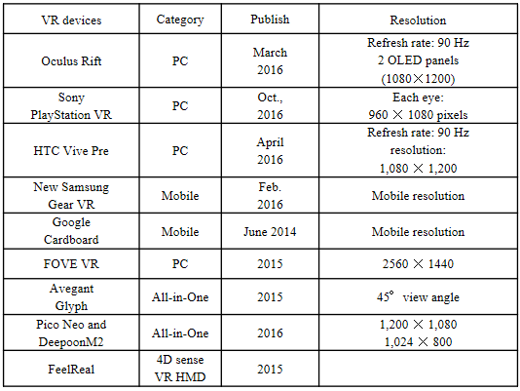
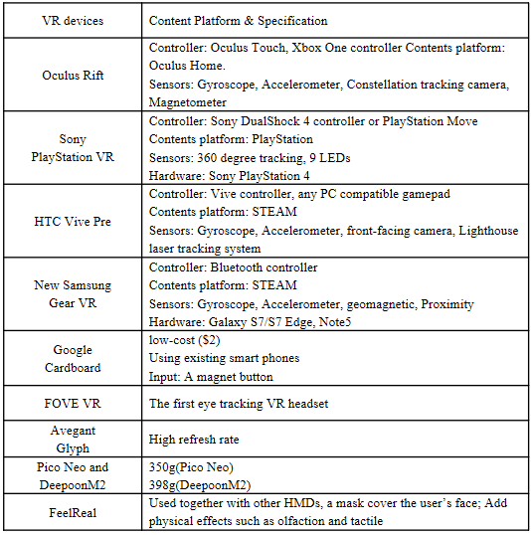
3.2 VR Applications
VR has significant applications in fields such as data and architectural visualization, medical treatment, military, aerospace, art, business, product design, manufacturing, and as enjoyable education or training tools. VR brings the users to the virtual world from outside to inside. For entertainment fields, it is used in games, movies, and scene experiences.

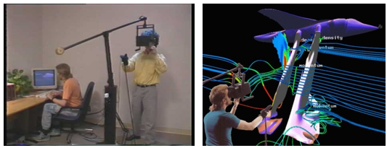
Fig.3. the Virtual Wind tunnel (VWT) system [11]

For Medical fields, Doctors employ VR to teach medical students in surgery, and cure patients and even help paraplegics regain body functions. In business, a variety of industries are benefited by VR technology. Especially carmakers create safer vehicles, and architects construct stronger buildings and even travel agencies use it to simplify vacation planning. Fig.3 shows an application of the VR interface technology to the visualization of the results of modern computational fluid dynamics simulations outside view (left), inside view (right) [11]. In the last few days, NBC used VR to live telecast the American president election debate. People who used Oculus Rift which owned by Facebook, HTC Vive, or Samsung Gear VR, et al., mainstream VR devices, download AltspaceVR, can watch it in a VR view, meanwhile they can set the image that though the role he can do some social activities. And such way was be token by NBC in the live telecast during the Rio Olympic 2016.

For educational fields, Students can use a VR device observe how the macrocosm or microcosmic world works as if it is happening around them, or see the internal structure of the human body show in Fig.4, these applications give them vivid effects which traditional education resources cannot supply, such as galactic kinematics; Atomic Structure or Atomic motions. Besides, VR is more useful and meaning for in the Training course, such as flight training, operation training, other skill training.

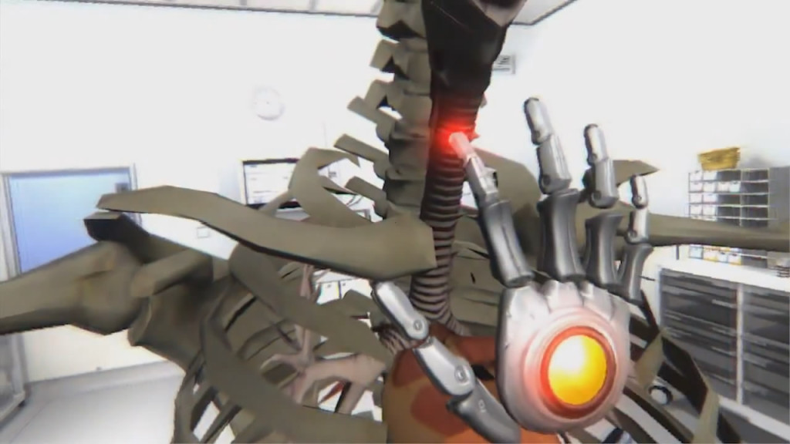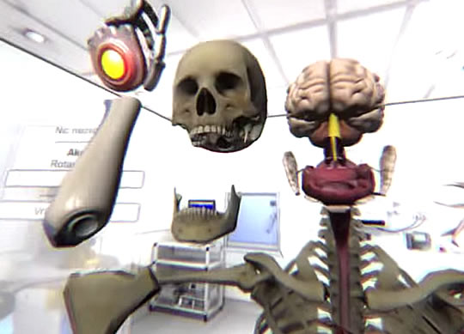
Fig.4. World of Comenius – Use Leap Motion Interact with the Virtual human body with just hands [13]

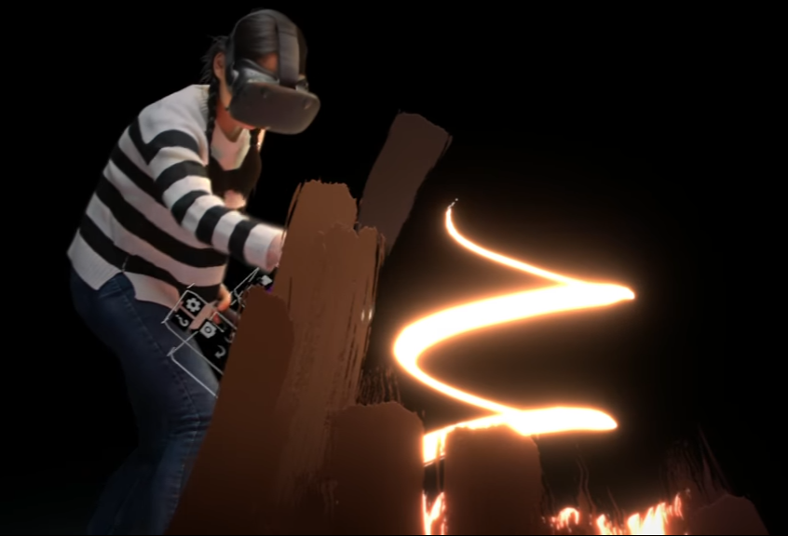
Fig.5. Tilt Brush: Painting from a new perspective [14]

For Artistic Designing, Google developed Tilt Brush in April, 2016, Fig.6[14], let users paint in 3D space with HTC Vive device. Google Earth VR was published in Nov. 2016 can explore the world from totally new perspectives with HTC Vive. Put the whole world within your reach. Take a peek at some of the incredible sights you'll experience along the way in the preview gallery in Fig.6 [12].

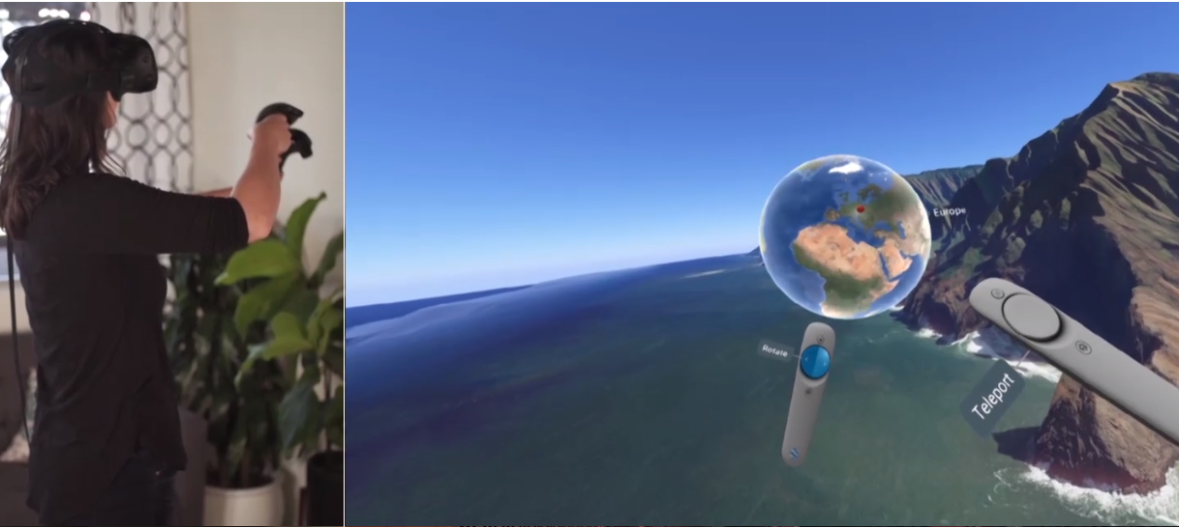
Fig.6. the Google Earth VR [12]

- CONCLUSION
This paper has provided a broad review of recent analysis in VR and VR system, limits of VR technologies, platforms, exemplified by relevant applications.

VR is a realistic image that is generated with typically software and presented to the user. In this paper, we described various VR devices and their characteristics, many applications in the Medical, Educational, Art and other fields, we also summarized the limits of VR technologies. Besides we have analyzed difference of recent VR devices such as Oculus Rift, Sony PlayStation VR, HTC Vive Pre, Samsung Gear VR, Google Cardboard, FOVE VR, Avegant Glyph, Google Daydream VR, Pico Neo, and DeepoonM2, and provided a review of recent issue of VR. Now VR has many proven applications in the fields mentioned above, however, to becoming more popularization the producer must break through its bottlenecks limits.

References and Notes

1. Jason Jerald, “The VR Book: Human-Centered Design for Virtual Reality”, ACM Books, Morgan & Claypool Publishers, October 16, (2015)
2. Slater, M., & Wilbur, S. “A framework for immersive virtual environments (FIVE) : Speculations on the role of presence in virtual environments”, Presence : Teleoperators and Virtual Environments, Vol 6(6), 603-616, December (1997), Article(CrossRef Link)
3. Lu Juan, “The Classification of Virtual Reality System”, Guide To Business, TP391.9, (2011), Article(CrossRef Link)
4. Integral VR system, Article(CrossRef Link)
5. 曹煊. 虚拟现实的技术瓶颈[J]. 科技导报, 2016, 34(15): 94-103.
CAO Xuan. Technological bottleneck of virtual reality. Science & Technology Review, 2016, 34(15): 94-103.
6. The Best VR, Article(CrossRefLink).
7. Sony, "PlayStation VR Launches October 2016", Sony. Retrieved, March, (2016), Article(CrossRef Link)
8. Ars Technica, "HTC Vive Pre impressions: A great VR system has only gotten better". Retrieved Jan.28 (2016), Article(CrossRef Link)
9. Alex Vlachos, "Advanced VR Rendering", Game Developers Conference, March, (2015), Article(CrossRef Link)
10. Kickstater, FOVE: The World's First Eye Tracking Virtual Reality Headset, Article(CrossRef Link)
11. S. Bryson, "The Virtual Wind Tunnel", Article(CrossRef Link)
12. Google Earth VR, Article(CrossRef Link)
13. Paul James, ‘world of Comenius’ Demonstrates Powerful Educational Interaction with Leap Motion and Oculus Rift, Oct 17,2014
14. Google, "Tilt Brush: Painting from a new perspective", 2016.

